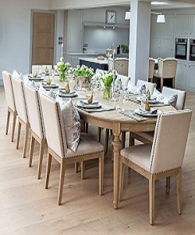

Modern Dining Table

$202.61

Availability: In stock

Description

Extending oak dining table with large oval wood table and set of 10 enticing nail-head trim light grey dining chairs, these fabric dining chair feature colored linen and cotton fabric upholstery on the seat and chair back. Sturdy hardwood frame with solid legs, it add stylish intrigue to your dining room and kitchen room. Assembly required.